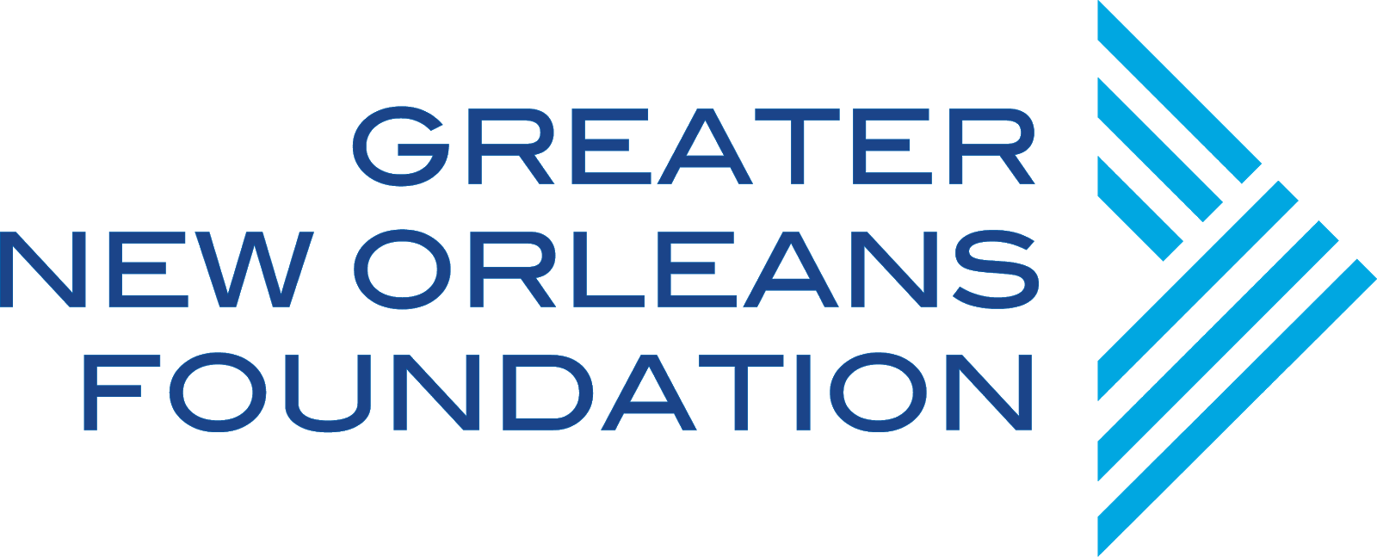Freeman Challenges Readiness Checklist

This checklist is intended to help organizations determine their readiness to participate in The Richard West Freeman Endowment and Board-restricted Reserve Challenges. It is recommended that more than one person in your organization, including the CEO, senior management, finance staff, development director, and/or board members, complete this checklist. The checklist includes criteria that demonstrate readiness for engaging in a fundraising campaign for either an endowment or board-restricted reserve. The results of the checklist will not only help organizations determine if they are ready to participate in one of the Challenges, the responses will also assist organizations in identifying their capacity building needs and priorities for building readiness for a fundraising campaign. A completed checklist is a required attachment to the grant application for both Challenges.

# Organization Name: Person Submitting the Checklist:

|  |  |  |  |  |  |
| --- | --- | --- | --- | --- | --- |
| **Capacities that should be in place before engaging in an endowment or board-restricted reserve fundraising campaign.** | **Not in Place** | **In Place, but Not in Practice** | **In Place and In Practice, but Needs Work** | **In Place, In Practice, and Working** | **Notes** |
| The organization has a clear vision for the future. |  |  |  |  |  |
| The organization has a track record for providing quality programs and services that meet a community need. |  |  |  |  |  |
| The organization is fiscally healthy and stable. |  |  |  |  |  |
| The organization has a successful track record raising money from individuals. |  |  |  |  |  |
| The organization’s board engages in fund development. |  |  |  |  |  |
| The organization has systems and infrastructure for donor management and stewardship. |  |  |  |  |  |



|  |  |  |  |  |  |
| --- | --- | --- | --- | --- | --- |
| **Capacities that will help you get ready for an endowment or board-restricted reserve fundraising campaign.** | **Not in Place** | **In Progress** | **In Place and Needs Work** | **In Place, In Practice, and Working** | **Notes** |
| Board members are clear on the purpose of an endowment/board-restricted reserve. |  |  |  |  |  |
| Board members established and approved an endowment/board-restricted reserve goal. |  |  |  |  |  |
| Board members established a board resolution and policy for the endowment/board-restricted reserve. |  |  |  |  |  |
| The organization established an endowment/board-restricted reserve fundraising plan that blends with the organization’s fund development plan. |  |  |  |  |  |
| Staff are assigned to execute the endowment/board-restricted reserve fundraising campaign. |  |  |  |  |  |
| The organization developed a communications strategy and materials for the fundraising campaign. |  |  |  |  |  |

Review all of the responses to the checklist with your team and develop the priorities for building readiness to participate in one of the Freeman Challenges. Develop an action plan with key capacity building activities, resources needed, assignments, and timelines.

|  |  |  |  |  |
| --- | --- | --- | --- | --- |
| **Activities** | **Resources Needed** | **Who is Responsible** | **Timeline** | **Notes** |
|  |  |  |  |  |
|  |  |  |  |  |
|  |  |  |  |  |
|  |  |  |  |  |
|  |  |  |  |  |