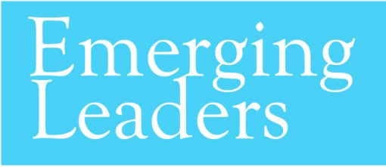

Organization Acknowledgement Form
Instructions: Please print in the below spaces and sign at the bottom of the form. This form can be scanned and emailed back to Rachel Swan at rachel@gnof.org.

I, _______________________________ am the Executive Director of ____________________________. I acknowledge that ________________________________________ is applying for the Greater New Orleans Foundation’s Emerging Leaders program.
I am aware of the commitments required of my employee in order to be a part of this program and I give my consent for my employee to sign up for the Emerging Leaders program (please intial boxes and sign below):
________ I have reviewed the fact sheet for Emerging Leaders.

________ I understand and support the commitments required of my employee in order to be a part of this program, including:
- Implementation of an organizational focused action-plan
- Attendance at all Emerging Leaders required meetings.

_____________________________________ _______________________
Signature Date

