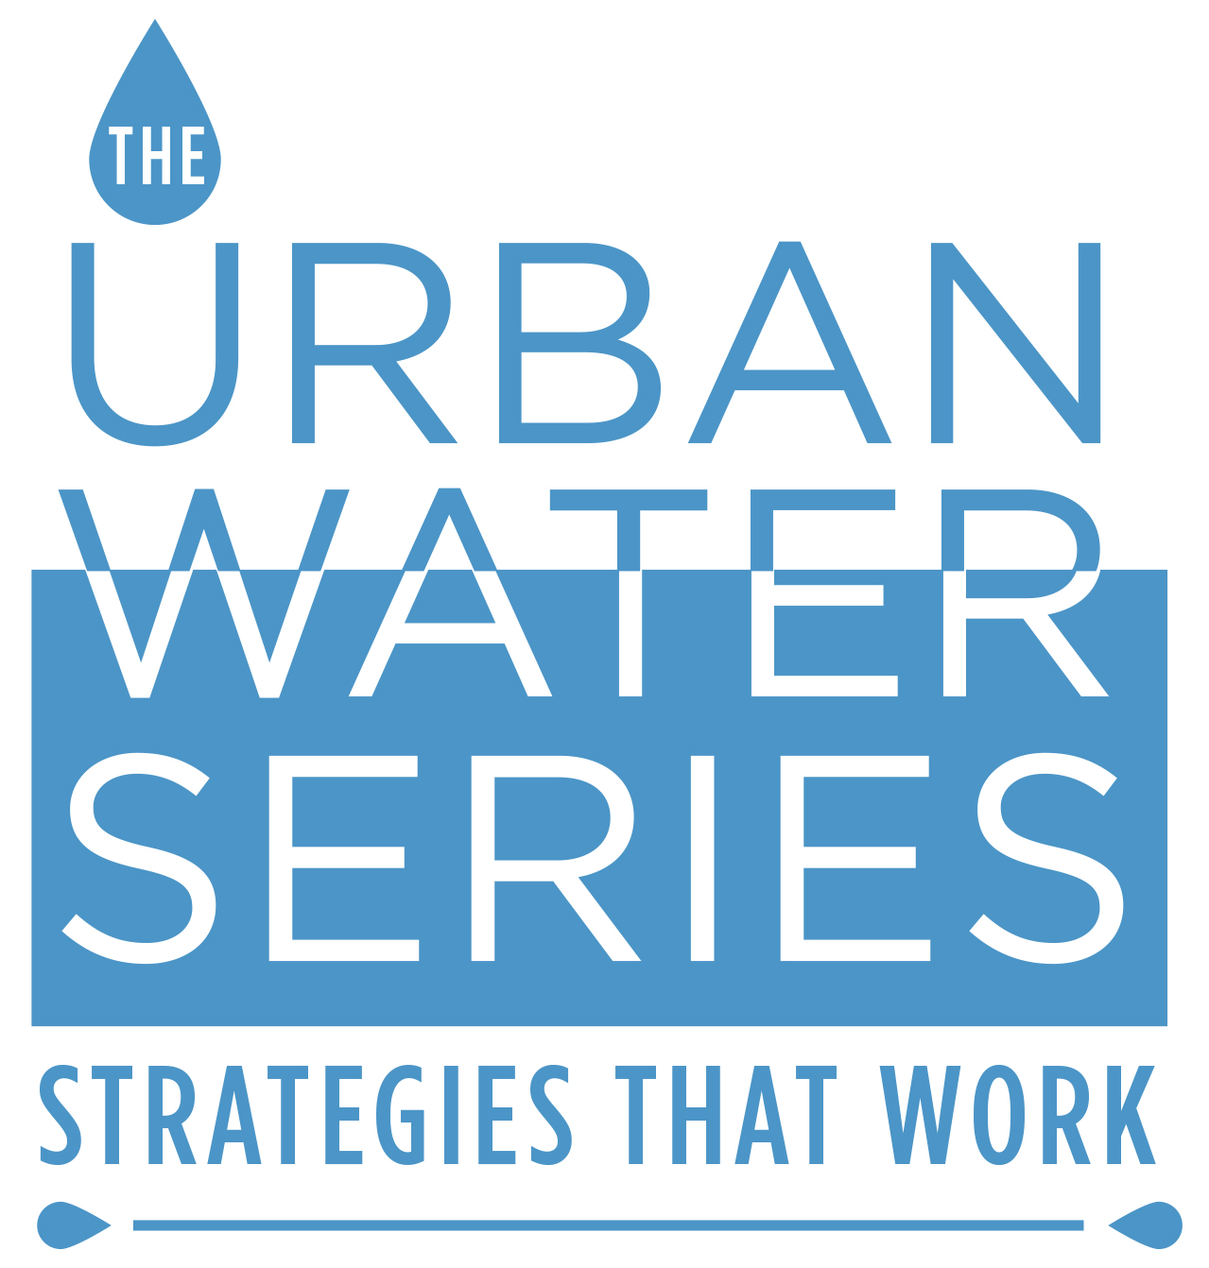
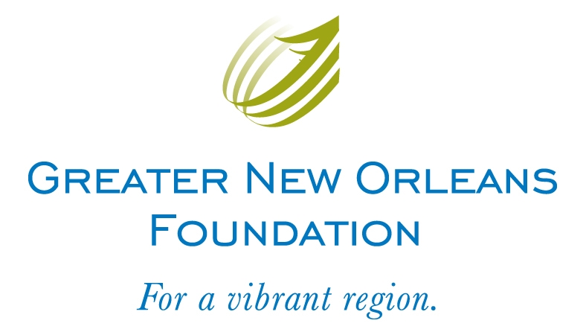

FOR IMMEDIATE RELEASE
Media Contact:
Gretchen Hirt
(o) 504.324.4242 | (c) 504.338.8460
Gretchen@gambelpr.com

Greater New Orleans Foundation and Urban Institute Present

Urban Water Series: Strategies That Work

Five workshops on how other U.S. cities are turning their water challenges into water assets

New Orleans, LA (May 14, 2013) – More than ever, issues of flooding, subsidence, aging infrastructure, and financial sustainability demand fresh perspectives and new approaches. The Greater New Orleans Foundation, Urban Institute, and over 30 community partners are proud to present: Urban Water Series: Strategies That Work, a series of five workshops to learn how other U.S. cities, with problems and challenges similar to those in New Orleans, have introduced innovative water management and financing. This series is intended to jumpstart a citywide conversation about our water challenges – and possible solutions.

Kicking off on Wednesday, May 15, the Urban Water Series’ five workshops will take place from 4:30 – 6:00 PM, on the Wednesdays: June 5, June 19, June 26, and July 10. All workshops are free, open to the public, and will be held at the New Orleans BioInnovation Center, 1441 Canal St. New Orleans, LA 70112. During the series, regional and national experts from such cities as Portland (OR), Houston, Milwaukee, Philadelphia, and Washington, D.C., will share what has worked for them and how those lessons might apply to New Orleans and the region.
“The cities that will thrive in the future are those that successfully integrate green infrastructure practices into all their water policies, most significantly in how they manage stormwater” said Director of Innovation in Infrastructure, Dr. Sandi Rosenbloom, with the Urban Institute. “Green infrastructure approaches to stormwater management bring multiple social, economic, and environmental benefits to the community. And green infrastructure measures directly involve citizens in making crucial water management decisions about their streets and neighborhoods as well as the city and the region.”
“We can no longer afford to continue to ‘fix’ our problems by investing, over and over again, in upgrades to our conventional infrastructure,” said Marco Cocito–Monoc, director of regional initiatives at Greater New Orleans Foundation. “The time is now to find new and sustainable solutions to our water challenges. We invite those who have an interest in the city and the region’s strategies to join us and our partners.”

Urban Water Series: Strategies That Work Workshop Schedule:

- Workshop 1- Stormwater Challenges; Local and National Perspectives (Wednesday, May 15 from 4:30PM – 6:00PM) Start off with a broad understanding of New Orleans’ current water challenges. Attendees will learn about the state of wetland loss, the EPA consent decree, Federal Clean Water Act, and New Orleans’ plans to improve water infrastructure. Speakers will also highlight best practices in stormwater management nationally.

- MORE -
Speakers include: Noah Garrison, a National Resources Defense Council attorney and the senior author of Rooftops to Rivers II: Green Strategies for Controlling Stormwater and Combined Sewer Overflows; Mark Davis, Director of the Institute on Water Resources Law and Policy; and Jeffrey Thomas, Principal of Thomas Strategies

- Workshop 2- Metropolitan and Comprehensive Green Stormwater Strategies (Wednesday, June 5 from 4:30PM – 6:00PM) From bayous to rain gardens, Houston and Philadelphia have brought nature back into the city as a way to control rainwater. Attendees will discover how and hear about the role community involvement has played in raising funds and protecting watershed areas.

Speakers include: Michael Talbott, Director of Harris County Flood Control District (Houston, TX); and Julie Slavet, Executive Director of the Tookany/Tacony-Frankfurt Watershed Partnership (Philadelphia, PA)

- Workshop 3- Green Alleys, Streets, and Neighborhoods (Wednesday, June 19 from 4:30PM – 6:00PM) Milwaukee and Portland have found affordable, green solutions for managing stormwater at the neighborhood level with permeable streetscapes, bioswales, green roofs, and rain barrels. Attendees will learn how these green infrastructure projects help absorb rainwater and relieve pressure on aging stormwater systems.

Speakers include: Karen Sands, Manager of Sustainability at Milwaukee Metropolitan Sewerage District (Milwaukee, WI); and Bill Owen, Senior Engineer at Bureau of Environmental Services (Portland, OR)
- Workshop 4- Innovative Financing Options for Green Stormwater Infrastructure (Wednesday, June 26 from 4:30PM – 6:00PM) Incentives for businesses and homeowners to manage stormwater on site have encouraged communities across the country to go green. Attendees will hear how innovative public-private partnerships as well as creative funding sources, such as charging people for letting stormwater run off their property in Washington, D.C., can help pay for green infrastructure.

Speakers include: Brian Van Wye, Branch Chief of Stormwater Program Implementation, District of Columbia Department of the Environment (Washington, DC); and Charlotte Kaiser Director of Finance at The Nature Conservancy

- Workshop 5 – Creating Local Change; Making a Commitment to Next Steps (Wednesday, July 10 from 4:30PM – 6:00PM) Discuss what New Orleans can learn from other vanguard cities – and what they can learn from us. This critical final session will bring together learnings from the entire series and empower attendees to move the conversation forward. It is our hope that we will leave this session with a list of next steps that we can pursue collectively as a community.

Moderator: Jeff Eger, Executive Director of the Water Environment Foundation; and David Waggonner, Principal of Waggonner & Ball Architects.

To register, visit www.gnof.org/urbanwaterseries or contact Julia MacMullan at 504.598.4663 or Julia@gnof.org. Advance registration is strongly encouraged as space is limited.

The Urban Water Series is presented by the Greater New Orleans Foundation and the Urban Institute in partnership with the American Society of Landscape Architects; BioDistrict New Orleans; Bureau of Governmental Research; Business Council of New Orleans; CH2M-Hill; City of New Orleans; Center for Planning Excellence; Coastal Protection and Restoration Authority; Dana Brown Associates; Downtown Development District; Entergy; GNO, Inc.; Horizon Water Initiative; The Idea Village; LA Urban Stormwater Coalition; Lafourche Parish – Coastal Zone Management; New Orleans Business Alliance; New Orleans Chamber; New Orleans Redevelopment Authority; Parkway Partners; Plaquemines Parish – Coastal Zone Management; Regional Planning Commission; New Orleans Sewage and Water Board; South Central Planning and Development; St. Bernard Parish – Public Works; St. Tammany Parish; Thomas Strategies, LLC; Trust for Public Land; Tulane Institute on Water Resources, Law & Policy; Urban Land Institute; Waggonner & Ball Architects; and the Young Leadership Council.

About Greater New Orleans Foundation
The Greater New Orleans Foundation is the community foundation serving the 13-parish Greater New Orleans region. We design and lead initiatives that improve the region, connect donors to community needs, identify and support great nonprofits, and strengthen civil society. www.gnof.org.
About the Urban Institute
The Urban Institute gathers data, conducts research, evaluates programs, offers technical assistance overseas, and educates Americans on social and economic issues — to foster sound public policy and effective government. Fore more information, visit http://www.urban.org or call 202.833.7200.
###

